Inclusive Volunteering Guide:
a practical resource for inclusive environmental volunteering

Inclusive Volunteering Guide
A practical resource for inclusive environmental volunteering.

Contents

Acknowledgements 3
Bellarine Catchment Network 4
Contributors 4
Part One: Introduction 5
Dealing with discrimination 6
Part Two: Wadawurrung and First Nations peoples 7
Being Inclusive: Practical Actions 10
Part Three: CALD communities 13
Being inclusive: Practical Actions 15
Part Four: People with disabilities 18
Being Inclusive: Practical Actions 19
Part Five: People who are LGBTIQA+ 22
Being Inclusive: Practical Actions 24
Conclusion 28
Inclusive Volunteering Checklist 29
Appendix 1: Wadawurrung Word List 32
Appendix 2: Language Guide – Swahili, Arabic and Persian 33
Appendix 3: LGBTIQA+ Flags 37
References 38

Acknowledgements

Inclusive Volunteering Guide
Bellarine Catchment Network, Victoria, 2023

Published by Bellarine Catchment Network Inc.
865 Swan Bay Road, Mannerim, Victoria, 3222
www.environmentbellarine.org.au
www.bgevc.com

Copyright 2023 Bellarine Catchment Network
All rights reserved. No portion of this publication may be reproduced in any form without permission from Bellarine Catchment Network. Supported by the Victorian Government.
Contact info@bcn.org.au for information

Bellarine Catchment Network wishes to Acknowledge the Wadawurrung, the Traditional Owners of the land on which we work, live and volunteer, and pay our respects to their Elders past, present and future, and recognize their continuing connection to land, water and community.
Bellarine Catchment Network Acknowledges LGBTIQA+ Elders, past, present and emerging who lead the way in change and recognition.
To learn more about what the Wadawurrung Traditional Owners Aboriginal Corporation (WTOAC) and what they aim to achieve, read their Palerrt Tjaara Dja 'Let's make Country good together 2020 – 2030: Wadawurrung Country Plan'. Visit: www.wadawurrung.org.au

Artwork: Thank you to proud Wadawurrung artist BJ O’Toole. Follow them at @papul_art (Instagram) and @papulaborginalart (Facebook)

Bellarine Catchment Network

Bellarine Catchment Network (BCN) is an independent, not-for-profit organisation overseen by a volunteer committee of management. We are an integrated and collaborative network consisting of 35 different community organisations, ‘Friends of’ groups, land managers, Landcare and Coastcare. Our collective goal is to protect and conserve our catchments, coastal areas and inland bushlands with strong connections to our local communities. BCN works through and for the network groups and organisations and the wider community to achieve these outcomes.
Our mission is to be an integrated, inclusive and collaborative network that educates, facilitates, connects and empowers groups and individuals to care for the living things of the land and water of the Bellarine catchment.

Contributors
This document was created in consultation and partnership with the Wadawurrung Traditional Owners Aboriginal Corporation, Cultura, Geelong Rainbow and GenU and we acknowledge the intellectual property that they provided us with for the purpose of this document. We encourage all readers to engage with these organisations to learn more, especially in regards to your specific volunteering or operations.

Wadawurrung Traditional Owners Aboriginal Corporation
admin@wadawurrung.org.au
www.wadawurrung.org.au
86 Mercer Street, Geelong, Victoria, 3220
Cultura
connect@cultura.org.au
www.cultura.org.au
25-41 Arunga Avenue, Norlane, Victoria, 3214
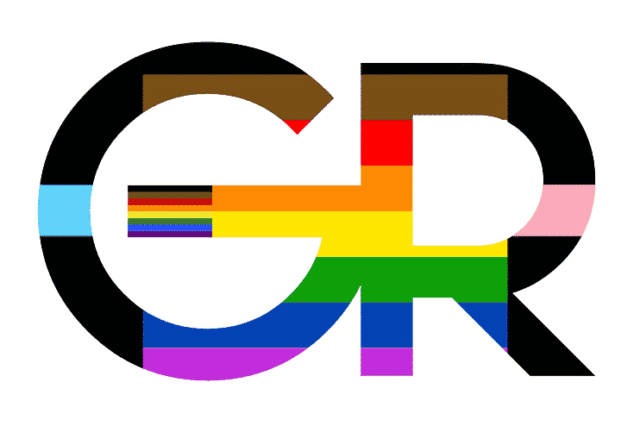
Geelong Rainbow
hello@geelingrainbow.org.au
www.geelongrainbow.org.au
Geelong West Community Hub, 89 Autumn St, Geelong West, Victoria, 3218

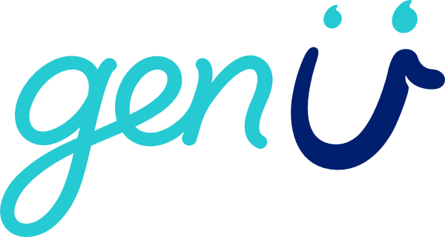
GenU
contact@genu.org.au
www.genu.org.au
Highton office, 21-29 Reynolds Road, Highton, Victoria 3216

Part One: Introduction

In 2022, the Victorian Government released the ‘Victorian Volunteering Strategy’, a document aimed at identifying ways to engage volunteers in the post-covid era. The Victorian Government provided $1 million in grants to support local partnerships and innovation projects to re-engage volunteers, broaden the volunteer base, and strengthen volunteering in local communities. This program was entitled the ‘Emerging Stronger’ grants program.
Bellarine Catchment Network were grateful to receive funding from this grant program to undertake to create this co-authored ‘Inclusive Volunteering Guide’ – a resource for any environment volunteer group wanting practical ways to ensure that volunteering is inclusive for all people.

Purpose of this document
The purpose of this document is to provide volunteer managing organisations (any group, volunteer or staffed, who offers volunteering opportunities) with the following:
- Background information about often marginalized groups that may not volunteer frequently
- Background information about barriers to volunteering
- Practical ways to be more inclusive
- Tools, resources, links and templates
- Further reading and resources.

Why inclusive volunteering
Everybody, no matter their background, abilities, language or how they identify, should be encouraged to volunteer. Volunteering has many benefits; from improvements to physical and mental wellbeing, helping to build social connectivity, building pathways to employment and much more. There are many people in our community who may find volunteering difficult, whether that be because of physical, social or unintended barriers. Creating safe, inclusive spaces and volunteering opportunities is essential to ensuring that all people can volunteer. It is simply the right thing to do.
People from many communities can experience unsafe situations, spaces and scenarios that perpetuate discrimination and exclusion. This includes First Nations peoples, people of colour, people with disabilities, people who speak English as a second language and people who are gender and sexually diverse. It is important to recognize that we can unintentionally have an ‘unconscious bias’ towards groups of people that can contribute to these unsafe situations. The Australian Human Rights Commission describes unconscious bias as “learned stereotypes about certain groups of people that are formed outside of conscious awareness. They are automatic, unintentional, deeply engrained in our beliefs, universal and have the ability to affect our behaviour” [1]. Unconscious bias can develop from our culture, personal experience, our families, friends, local communities, the media and information that we engage with. It can come in many forms and can often be difficult for people to identify. Recognizing and doing the work to overcome our unconscious bias is a very important step towards authentic inclusiveness. To find out more about unconscious bias, read this article by ‘The Culture Movement’ [2].

Dealing with discrimination

As a volunteer manager, you may experience a situation where a volunteer or participant may make harmful comments or exhibit discriminatory behaviour towards people or communities featured in this resource. The following are some strategies to help you manage these potential events in a positive way.
Develop a Code of Conduct
A Code of Conduct policy is a simple document that outlines the expected behaviour and responsibilities of volunteers and staff working with and for an organization or group. A Code of Conduct can outline that you expect volunteers and staff members to abide by the law and that discrimination or harassment of any kind will not be tolerated. A Code of Conduct can also include what values your organisation aligns to; for example, values like respect and inclusivity. By outlining these expectations and values in a formal way, they can be used as a discussion point if ignored. This keeps any disciplinary action focused on the behaviour, not the person and forms the basis of any discipline.
To create your own Code of Conduct, download this free template by ‘Resources by Employers’ click here

Training
If you feel that volunteers need to understand more about First Nations, people with disabilities, people who are LGBTIQA+ or people from the CALD community, consider booking a training session for your volunteers. Organisations like GenU and Cultura facilitate formal training on topics such as disability awareness and cultural humility. Training provides participants with a deeper understanding of each community and demonstrates the behaviour and culture that your organization or group expects.

Managing Conflict
There may be a situation when a volunteer exhibits harmful behaviour. This situation can be awkward and upsetting, but can be managed with the following tips:
- Have a calm conversation about why the comments or actions were harmful
- Remind them about the behaviours and culture that volunteers are expected to display
- Note that any harmful behaviour will not be tolerated and may result in disciplinary action
- Speak to the volunteer/participant who has been harmed to ensure that they feel safe and supported. You may want to fill out an incident report form depending on the severity of the comment.

For any advice on this matter, contact volunteering support agencies such as Volunteering Victoria or Justice Connect.

Part Two: Wadawurrung and First Nations peoples

Australia is made up of many different and distinct Aboriginal and Torres Strait Islander groups and they each have their own culture, beliefs, practices and language [3]. Aboriginal and Torres Strait Islander peoples are the first peoples of Australia, meaning they were here for thousands of years prior to colonization [3]. Aboriginal and Torres Strait Islander peoples live in all types of places, from urban, regional and remote areas, and are present in all communities. They do not necessarily live on their Traditional lands or islands [3].
The current definition, proposed by the Commonwealth Department of Aboriginal Affairs in the 1980s, is that an Aboriginal and/or Torres Strait Islander person is:
- of Aboriginal and/or Torres Strait Islander descent
- identifies as an Aboriginal or Torres Strait Islander
- is accepted as such by the community in which they live or have lived.
This definition is very broad and is often reserved for specific situations such as applying for Indigenous-specific services or programs. Each community has their own means of identification which can be acknowledged via an authentic conversation [3].

Registered Aboriginal Parties (RAPs)
The Victorian Aboriginal Heritage Act 2006 recognises Registered Aboriginal Parties (RAP) as the “primary guardians, keepers and knowledge holders of Aboriginal Cultural Heritage” [4]. RAPs are considered the main source of advice and knowledge on Aboriginal places or Aboriginal objects in their region [4]. Some of the core functions of a RAP include:
- evaluating Cultural Heritage Management Plans
- assessing Cultural Heritage Permit applications
- making decisions about Cultural Heritage Agreements
- providing advice on applications for interim or ongoing Protection Declarations
- entering into Aboriginal Cultural Heritage Land Management Agreements with public land managers
- nominating Aboriginal intangible heritage to the Victorian Aboriginal Heritage Register and managing intangible heritage agreements [4].
As of March 2023, there are currently 11 RAPs across Victoria - to find out what Country you are on, visit the Victorian Aboriginal Heritage Council’s page on Registered Aboriginal Parties (RAPs): https://www.aboriginalheritagecouncil.vic.gov.au/victorias-current-registered-aboriginal-parties
To find out what Country you are on, use this Online Map Tool: click here

Wadawurrung Traditional Owners Aboriginal Corporation (WTOAC)
The following text was sourced from www.wadawurrung.org.au with correct approvals.
The Wadawurrung people are the Traditional Owners of the land of the Bellarine Peninsula and Geelong, among other places. Their family have looked after and cared for this Country, or Dja, for over a thousand generations, and are still caring for it to this very day. The Wadawurrung Traditional Owners Aboriginal Corporation (WTOAC) is the Registered Aboriginal Party (RAP) for Wadawurrung Country. The WTOAC are the statutory authority for the management of Aboriginal heritage values and culture and were appointed in May 2009 as a Registered Aboriginal Party under the Victorian Aboriginal Heritage Act 2006. Their area covers over 10,000 square kilometres on the western side Melbourne and including the major regional cities of Geelong and Ballarat [5].
The Wadawurrung are the seven family groups who are the sole descendants of John Robinson, their apical ancestor. Descendants of John Robinson researched their ancestry and succeeded in 1997 to acquire enough information to be recognised as Traditional Owners [5].
In support of their above responsibilities, WTOAC provide a wide variety of services to organisations, assisting them in compliance with the aforementioned Act. They provide field representatives to assist with the discovery and repatriation of cultural heritage artefacts and ancestral remains and their induction programs help to acquaint individuals and organisations with local heritage. WTOAC, representing Wadawurrung Traditional Owners, also coordinates the performance of ceremonial duties. These include Welcome to Countries and Smoking Ceremonies for community groups, corporations, events and special occasions where cultural protocols are valued and practiced [5].
From the early 1800s the lives of Wadawurrung people became permanently changed when Europeans invaded their Country that provided year-round abundance of food. The grassy plains, waterways, wetlands, coastal and sea Country were taken over by squatters, eaten by sheep and cattle and cleared for farming and urban development. European interactions had a devastating effect on Wadawurrung ancestors that continue to be felt deeply by their people today. Dispossession, disease and massacres decimated their people despite the efforts of our warriors and resistance fighters. The thousands of Wadawurrung in clans and family bands were diminished to a fraction of our population, around 70 individuals [5].

Figure 1 (below): Map of Wadawurrung Country from ‘Paleert Tjarra Dja – Let’s make country good together 2020-2023 – Wadawurrung Country Plan’

Please note that this that this map is current as of March 2023 but may change as Treaty and other land and water negotiations progress.

Paleert Tjarra Dja – Let’s make country good together
The following text was sourced from www.wadawurrung.org.au with correct approvals.
The Paleert Tjarra Dja – Let’s make country good together - Wadawurrung Country plan is the collective dream and direction for the future of Wadawurrung people and Country. It tells the story of what is important to the Wadawurrung, and what needs to be done about it. It will be a guide for building upon cultural heritage management work and progressing the broader Caring for Country aspirations. The plan will also help us strengthen Wadawurrung people's cultural knowledge and education to be able to develop our land and sea management program, pursuing purchases, access and co-management arrangements for Country.
The plan will help guide our Treaty, Traditional Owner Settlement Act and Native Title negotiations, and our conversations with government, and other partners.
Read the plan here: Paleert Tjarra Dja – Let’s make country good together 2020-2023 Wadawurrung Country Plan’

Learn more
Victoria’s Treaty: Find out more about this Treaty that aims to acknowledge the sovereignty of First Nations and to improve the lives of First Peoples. https://www.firstpeoplesrelations.vic.gov.au/treaty
Voice to Parliament: Learn about the Voice to Parliament constitutional amendment and why it is important to ensure that policies are made with Aboriginal and Torres Strait Islander people, rather than for Aboriginal and Torres Strait Islander people. https://fromtheheart.com.au/what-is-a-voice-to-parliament/
Mother Tongue: Learn more about Australia’s first languages through ABC’s YouTube playlist: https://www.youtube.com/playlist?list=PLmWe-V9tacwHqIfIBPvZMThlaYH6gH2u0
Wadawurrung Language App: Learn about how the Wadawurrung language. https://apps.apple.com/us/app/wadawurrung-language-intro/id1511858036
Songtime: Listen and learn these songs about Wadawurrung stories via the team at Songtime. https://www.songtimes.au/people

Being Inclusive: Practical Actions

Educate yourself
The first way to ensure that you are developing and facilitating volunteering that is inclusive for Wadawurrung and other First Nation peoples, is to learn more about their tens of thousands of years of history. This history includes learning about their deep connection to Country, as well as the horrific acts of genocide forced upon First Nations people that continues to cause harm. This is a necessary step towards true reconciliation and inclusiveness. You can research this history yourself via reputable sources, but also consider undertaking cultural humility training with your Traditional Owners out on Country. There are many grants that fund these types of activities and are a great way to start building strong relationships with Traditional Owners and local RAPs.

Be collaborative
One of the best ways to be inclusive is to collaborate and engage directly with organisations like WTOAC and other First Nations peoples. Designing and coordinating volunteering out on Country can be an empowering opportunity that can instill a deep connection between participants, First Nations and the Country. As the WTOAC are the RAP for all of Wadawurrung Country spanning across Geelong, the Bellarine and the Surf Coast, they are highly sought after. Booking consultations, ceremonies and services should be done well in advance. Many grants will fund these consultations and services, so look to include this in your next budget. Once you have booked WTOAC or other RAP representatives, make sure that you understand and communicate the requirements and conditions of their services.

Being mindful of cultural heritage
Another way to ensure that you are being inclusive out on Country is to check if you are volunteering in places with cultural heritage. Coastal dunes for example have significant cultural heritage value due to the presence of middens, ochre, artefacts and places of cultural business. Being aware of this and acting sensitively in how we work in these spaces is hugely important in order to cause no harm and protect cultural heritage for the future.

Intellectual property
First Nations peoples such as the WTOAC own the intellectual property of their language, stories, knowledge and artworks. It is important to recognize this to ensure that this intellectual property is used appropriately, and in consultation with First Nations. For example, is inappropriate and potentially illegal to:
- Use artwork from a First Nations artist for documents and designs without consultation/approval
- Use language that has not been approved
- Tell Wadawurrung stories and knowledge without consultation
- Take photos or footage at official ceremonies without prior permission.

Engage First Nations businesses
If you are hosting an event, consider engaging and hiring First Nations businesses to promote inclusiveness and equity. Some businesses that frequent the Geelong region include Black Brew, a coffee service, and Larrakia Bilirra – infrastructure services company including traffic maintenance.

Doing an appropriate Acknowledgement of Country
If you are hosting an event or activity, you may need to know who can do a Welcome to Country and an Acknowledgement of Country. A Welcome to Country is delivered by Traditional Owners to welcome visitors to their Country, where as an acknowledgement of Country can be done by anyone and is an opportunity to show respect for Traditional Owners and their Country [7]. There is no specific wording for an Acknowledgement of Country, however it is best to be sincere and know a bit about the Country that you are on [7].
Incorporating an Acknowledgement of Country and Welcome to Country into events shows respect by upholding Aboriginal and Torres Strait Islander cultural protocols. Taking the time to Acknowledge Country, or including a Welcome to Country at an event, reminds us that every day we live, work, and dream on Aboriginal and Torres Strait Islander lands. Aboriginal and Torres Strait Islander peoples have experienced a long history of exclusion from Australian history and an authentic acknowledgement contributes to ending the exclusion that has been so damaging.
Suggested wording could include: “I would like to begin by acknowledging the Traditional Owners of the land on which we meet today, the [Wadawurrung] People. I would also like to pay my respects to Elders past, present and emerging.” [8]

Planning and facilitating volunteering

Naming Country
When you are promoting your volunteering events, mention the Country that you are on. You could either do this by listing it in the body of your post – for example; “Join us for a weeding session at Clifton Springs, Wadawurrung Country.” On Instagram, you can also include the Country in the location option by writing in the suburb followed by the Country, or just use ‘Wadawurrung Country.’ You can do the same thing on posters, flyers and event registration systems. See Figure 2 on the following page as an example.
Flags
Displaying the Aboriginal and Torres Strait Islander flag at your volunteering events is a visual and effective way to demonstrate that your volunteering is a safe cultural space. You can either purchase a flag from a reputable company, or create your own design and print it out. See Figure 3 below as an example. Wearing a lapel pin with these flags is another way to demonstrate that your volunteer coordinators are welcoming to First Nations. Melbourne based company Clothing the Gaps offer many affordable enamel pins on their website.

Using language
A great way to promote and educate volunteers about the WTOAC at events and opportunities is to use approved language when addressing volunteers. For example, using the phrase ‘Nyurra Wurriyn’ instead of ‘how do you do’ or ‘Gobata’ instead of ‘take care.’ There are many phrases and words for plants and animals in Wadawurrung that you can promote via their language app, however consultation and approval directly with the WTOAC is always preferred.
It is also important to know that the word ‘Aborigine’ is an offensive word and should not be used. It is preferable to use and capitalise ‘First Nations,’ ‘Aboriginal’ and/or ‘Torres Strait Islander.’ [3]

Figure 2 (left): An example of a poster promoting volunteering with the inclusion of Traditional Owner Country in the location.
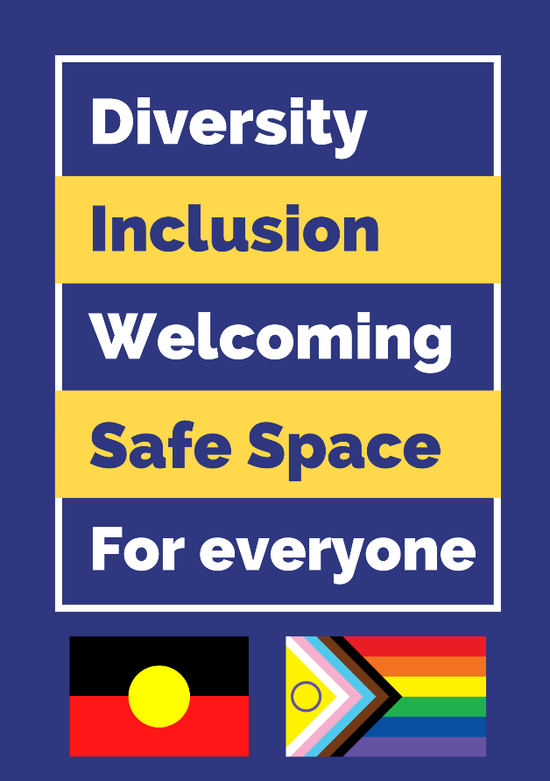
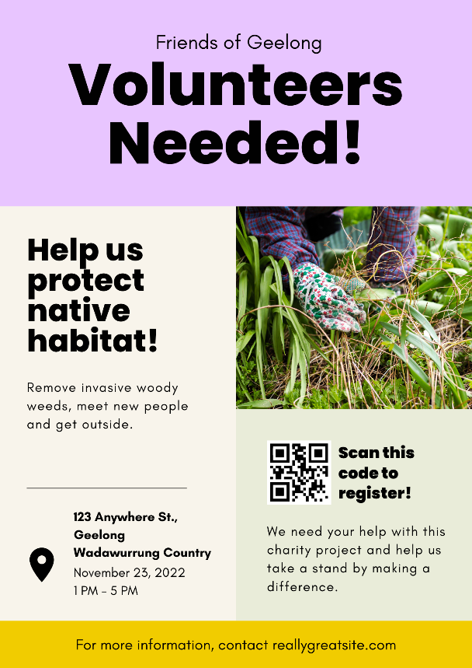
Figure 3 (right): An example of a poster used at events to welcome First Nations peoples, as well as gender and sexually diverse people. Click here to download a PDF version of this poster to display at your own event.

Appendices
- Appendix 1: Wadawurrung Word List

Part Three: CALD communities

CALD is an acronym that stands for ‘Culturally and Linguistically Diverse’ and is used as broad term to describe communities with diverse languages, backgrounds, nationalities, traditions, culture and religions [9]. Generally, CALD describes people who are born overseas in countries whose primary language is non-English [9]. The greater Geelong area is home to many CALD individuals and communities and support agencies like Cultura have observed an increase in people from Afghanistan, Iran, Syria and Burma for example. In the past, the major CALD communities migrating to the greater Geelong region were from Italy and Greece, but this has been slowly changing [10].
Engaging with CALD individuals, families and communities requires an understanding of the diversity of cultures, values and beliefs, and a willingness to show humility and respect to all people. For example, many cultures have different social norms that may be unfamiliar with Anglo-born Australians and should not be considered inferior just because they are unknown or different [11].
Culture is often hard to identify as there are ‘visual’ shared cultural norms, from clothing, food, music and language, as well as many ‘invisible’ cultural beliefs and norms including body language, preferences for personal space, approaches to problem solving and concepts of self, time and family. However, despite cultures being defined as shared patterns of thinking or belonging, it is also constantly evolving with each generation and so must our understanding of culture. Do not assume that all individuals within a certain group or culture share the same values and beliefs [12].
To start learning about different cultures across the world, visit the SBS’ Cultural Atlas - https://culturalatlas.sbs.com.au/ or browse the Country Profiles within the Volunteering WA’s ‘A Common Purpose’ document – click here or see Figure 4 on the following page.

Cultural Humility
Engaging CALD communities in a truly inclusive way requires cultural humility, which is defined as “a personal lifelong commitment to self-evaluation and self-critique whereby the individual not only learns about another’s culture, but one starts with an examination of their own beliefs and cultural identities” [13]. Cultural humility requires individuals to be open, free from pride, self-reflective, show empathy and compassion, be “people-orientated” and to acknowledge any power imbalances. For example, cultural humility is identified when a volunteer manager takes the time to listen to a volunteer and develop opportunities with their input and support, rather than trying to make them fit within current opportunities that may not be appropriate, enjoyable or in-line with cultural beliefs or practices.

Cultura
Cultura are an organization servicing the Greater Geelong and Colac area with the intent to connect, inspire and embrace culturally diverse individuals throughout their life journey. They provide a support network and a unified voice for multicultural communities in Greater Geelong and Colac. They currently offer services in settlement services, youth and community programs, arts programs and cultural events, community services and aged care.
Cultura engage directly with CALD communities and are a gateway to multicultural communities that may be looking for volunteering opportunities that may be suitable to their lifestyle, culture, beliefs or values.

Learn more
SBS Cultural Atlas: a website featuring information about different cultures across the world. https://culturalatlas.sbs.com.au/
A Common Purpose - Formal Volunteering and Cultural Diversity: A document outlining how to rethink volunteering and country profiles to showcase cultural diversity. Click here
Cultural Safety: Principles and Guidelines: a helpful document to create a culturally safe space for all. Click here

Figure 4 (below): Afghanistan ‘Country Profile’ featured in the ‘A Common Purpose’ – Formal Volunteering and Cultural Diversity resource.
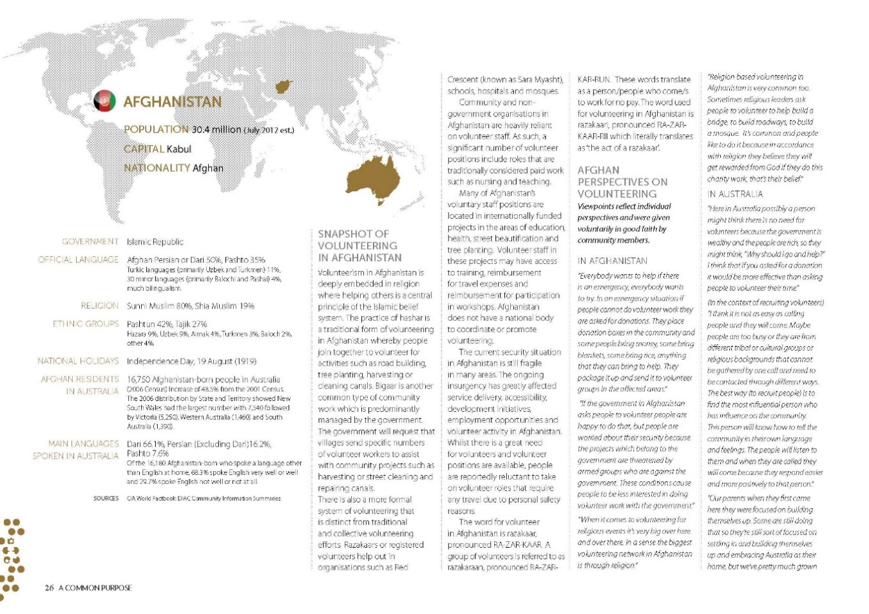

Being inclusive: Practical Actions

Educate yourself about the barriers
- People from CALD communities can face many, and different barriers to volunteering. By educating yourself about the different cultures present in the Greater Geelong area and how they live and work, we can better understand how to overcome certain barriers. For example, some people from CALD communities have arrived into Geelong as asylum seekers, or refugees, and may have come from war or other unsafe living conditions. These people may come here with no resources and may not be able to access a car, and may struggle with public transport.
- Other factors that can inhibit volunteering are that many volunteers may be the primary carer for their families, and do not have access to support to allow them to volunteer without their family.
- Language is an obvious barrier to volunteering and is one that many organisations are actively trying to improve. It is important to note that language barriers do not only refer to the difficulty that some face when learning a new language, but the fact that they may struggle with their own language. For example, subtitles on videos are seen as an inclusive way to engage people who speak another language other than English, but there are people who are unable to read and so this is not helpful to them. Note that language proficiency isn’t indicative of intelligence. Voice overs of interpreters are often one of the best ways to overcome this barrier.
- Finally, for some people arriving to the Greater Geelong area, they will undergo a huge cultural shift. Many CALD communities may have a lack of trust for official looking volunteering opportunities or oraganisations, and may have a general lack of trust for new organisations or places. A good way to think about this lack of trust is by imagining yourself in the same situation – if you just moved to a place where the people spoke a different language to you, behaved differently and had a different culture, would you be comfortable and willing to volunteer at a place you have never been?

Be collaborative
- Working collaboratively with CALD communities and support agencies like Cultura is an excellent way to ensure that your volunteering is inclusive and accessible. The staff at Cultura work closely with clients from CALD communities and have an excellent understanding of these barriers, as many are from the CALD community themselves.
- Consider building a relationship with community leaders who are trusted within their relevant communities and who can facilitate interactions with potential volunteers and their families. This will help to start building trust between individuals and your organization.
- Organise a ‘meet and greet’ activity at Cultura to allow clients to meet you and your organization in person. You could then organize a site visit so that potential volunteers are comfortable travelling to that location.

Planning and facilitating volunteering

Design inclusive
- When starting to design your volunteering opportunities, consider the barriers that participants may face and see if you can find solutions – e.g., funding to engage interpreters
- Learn about other cultures and identify any cultural differences that may clash with your opportunity
- Consider rethinking how you facilitate volunteering – this may take time and may require consultation with different members of the community
- Assess your volunteering opportunity and consider if you are asking a person to abandon or disregard their culture, values and behaviours?
- If appropriate, look to engage interpreters or bilingual support workers

Promoting volunteering
There are many ways to improve promotional methods and materials that is inclusive for people with CALD communities. Below are some options:
- When promoting your volunteering opportunity with the public, remember that in some countries, the word ‘volunteering’ does not exist and may not mean anything to them. Instead, promote the benefits of volunteering including:
  - building pathways to employment and providing an opportunity to learn new skills
  - caring for the local community
  - fostering social connections
  - practicing English
  - improving mental and physical wellbeing
  - becoming familiar with the local community and exploring new places
  - learning the culture
- An example of some wording around this could be: “Do you want to contribute to your community? Get outside of the house, explore new places and have a positive experience at our upcoming nature session.” Make it clear that volunteering is not just labor but has clear benefits to the volunteers.

Registrations
- Consider whether you need to screen potential volunteers via a police check, and if you do, how you can communicate this requirement sensitively. Police checks and screening can be very scary for the CALD community due to their perceptions of the police. Be sensitive to this and let them know why you are asking for this and how that information will be stored
- Ensure that registration and/or application forms include space for people to identify whether they require support or adjustments to support their participation in volunteering – for example, bilingual support workers/interpreters
- Consider that you may need to set up reminders or make follow up calls to participants about their attendance or what they should bring – don’t assume that registration will mean attendance
- You may need to organize transport or list the bus route and stop closest to your location for those using public transport

Social media
- Design your media/posters in a way that doesn’t look like the government as some volunteers may not trust the government
- In media/posters, use images showcasing diverse people so that participants can connect
- Use wording that is clear, concise and avoid technical terms, acronyms, sarcasm and satire. You can use the Hemingway App to check this: https://hemingwayapp.com.

Inclusive events
Below are some ways to facilitate events or volunteering activities that are supported, safe and inclusive. Note that there are many ways to do this which can be developed by consulting the communities themselves:
- Before running your event or activity, consider visiting these communities or places like Cultura to establish connections, build trust and to explain your volunteering opportunities in person. You could also organise a site visit for key community leaders so that they can guide other participants on the day
- Provide flexible and/or informal volunteering opportunities or tasks - for example seek participants to organize catering rather than weeding. In almost every culture, food is really important and is a unique way that participants can contribute
- Contact Cultura’s community development team to help promote your activities and events
- Design opportunities or events that are appropriate for participants to attend as a group or family. If this is appropriate, promote this on social media/media
- Consider bringing additional Personal Protective Equipment if it is required as some participants may not be aware and may not bring their own
- When catering an event, consider if your food is halal friendly which relates to how meat is prepared. There are some caterers in Geelong that can accommodate this, and the Healthy Living Centre at Cultura can accommodate small events
- When interacting with CALD participants, remember to smile, demonstrate active listening, avoid shouting, mumbling or speaking too fast.
- When meeting CALD participants, avoid stereotyping them regarding their appearance or based on their nationality or culture. Do not make assumptions about their religion, marital status, food preferences or any other personal preference
- Learn some basic greetings in different languages such as Tamil, Dari or Swahili to make participants feel welcome. The ‘Language Sheets’ in Appendix 2 can be used as a guide
- If participants behave in a way that is different to anglo-Australian culture – for example being late, littering, or speaking bluntly, try to not take offence and understand that these behaviours can be normal.

Appendices
- Appendix 3: Language Guides (Swahili, Arabic and Persian)

Part Four: People with disabilities

People with disabilities are experienced by people of all ages and the way that their disability is acquired is varied; it could either from birth or acquired through illness, injury, accident, or ageing. Around 18% of Australia’s population – approximately 4.4 million people – currently experience disability [14].
Disabilities can be long-term physical, mental, intellectual, cognitive or sensory disabilities. Not all people with a disability are the same – they may require different support mechanisms or systems and have their own identity formed by their cultural background, race, gender, age and sexuality. Some people with a physical disability may also have a mental illness like depression, otherwise known as a dual disability [15].
Many organisations support the ‘social model of disability’ described by People with Disability Australia (PWDA) as a model where “societal barriers are considered to be obstacles to a person’s equal participation, not their impairment. The social model rejects the medical model of disability, which sees disability as an individual deficit” [16].
All people, including people with disabilities, should feel supported in the volunteer sector. It is important to note that some people prefer ‘person-first language’ – e.g., people with disability, whereas some prefer ‘identity-first language’- e.g., disabled people [14]. It is encouraged to ask a person what their preference, or use ‘person-first’ language by default, as this focuses on the person, not the disability. As language can have the capacity to exclude, cause harm and humiliate, it is best to learn more about what is appropriate language when working with people with disability [14]. The People With Disability Australia’s ‘Guide to Language’ is a great tool to understand appropriate language for different types of disabilities, and why. Find out more: click here
It is important to recognize and treat people with disabilities based on their identity, not just their disability. Just like all people, people with disabilities want to feel welcome and part of a group, and volunteering is an excellent way of providing access to new skills, pathways to employment, social connection and improvements to physical and mental health.

Support agencies
The National Disability Insurance Scheme (NDIS) was established in 2013 to assist people with disabilities. Many people with disabilities may require supportive equipment and/or support workers, which are usually funded through the NDIS. Funding goes directly to the individual and their carers to pay for support and participation in programs, which may leave a gap between volunteer opportunities and the person with a disability. It is important to understand this model so that we can make changes to improve our engagement and relationships with potential volunteers.
GenU
GenU are a Victorian based organisation providing a variety of support services to metropolitan and regional communities. This includes disability support services including individual support, employment, accommodation and recreation activities. GenU facilitate many programs including structured sessions with carers and support workers to provide people with options to explore nature.

Learn more
Australia’s Disability Strategy 2021-2031: https://www.dss.gov.au/disability-and-carers/disability-strategy
International Day of People with Disability: www.idpwd.com.au
People With Disability Australia: www.pwd.org.au
People With Disability ‘Language Guide’ - https://pwd.org.au/resources/language-guide/
‘Easy Read’ guide - https://www.accessibility.sa.gov.au/introduction/easy-read
GenU Locations - https://www.genu.org.au/contact/

Being Inclusive: Practical Actions

Be collaborative
- Make sure that programs offered are what people want. Talk to clients, guardians and carers to see what they would be interested in. go through genu to do this
- Share volunteering opportunities with relevant support workers and staff at GenU including a calendar of events and volunteer information (example below). Accompanying this could be a statement to demonstrate that all are welcome to participate in your volunteering, from people with a disability as well as support workers.

Planning and facilitating volunteering
Design inclusive
To ensure that our volunteering options are in fact accessible and inclusive to all people, we should be designing volunteering opportunities to make them accessible and inclusive. Some things to consider when designing volunteering include:
- If volunteering locations have accessible parking and toilet options
- If the terrain at these locations is accessible for participants to navigate (e.g., wide, smooth tracks, generally flat terrain and low risk)
- If there are other activities or ways for people to contribute if main volunteering activities are not suitable for people with specific disabilities. Are there other skills that are required?
- Are volunteer coordinators trained/briefed with ways that they can support people with disabilities and their families/carers/support workers
- Can volunteering be designed in partnership with people with disability and their support workers?
- When applying for grants, consider adding in a budget to meet the support requirements of volunteers.

Promoting volunteering
There are many ways to improve promotional methods and materials that is inclusive for people with disabilities. Below are some options:
- Use diverse images of people in marketing materials and social media, including people of all races, genders, ages, cultures and people with disabilities
- Be clear about volunteering activities, requirements and any other information so that participants are fully aware of their role. Don’t assume that everybody knows what happens during a revegetation activity for example
- Provide information in accessible formats if required
- For people with low vision, ensure that you provide a Word Document version of any PDF that you produce as Word features accessibility features and works better with screen readers
- Promote the positive benefits including social connections, giving back, experiencing nature, improvements to physical and mental health.
Registrations
- Ensure that registration and/or application forms include space for people to identify whether they have a disability and space for them to identify any adjustments to support their participation in volunteering. Adjustments could include different types of tools/equipment for revegetation or reduced volunteering hours.
Social Media
- Promote your commitment to inclusivity in separate social media posts so that you establish a reputation for being inclusive and accessible
- Use ‘alternative text’ to accompany images on social media and/or digital formats like websites. Alternative text is a description of images which are read aloud by a screen reader. See Figure 5 below as an example
- In pre and post social and print media, focus on all of the people who contributed and participated, not their disability
- Ensure that you acquire consent and approval from participants, their families, guardians and/or support workers when utilizing photographs for marketing materials and social media.

Figure 5 (below): an Instagram post by @bellarinecatchmentnetwork and the accompanying alternative text describing the image to assist people with screen readers
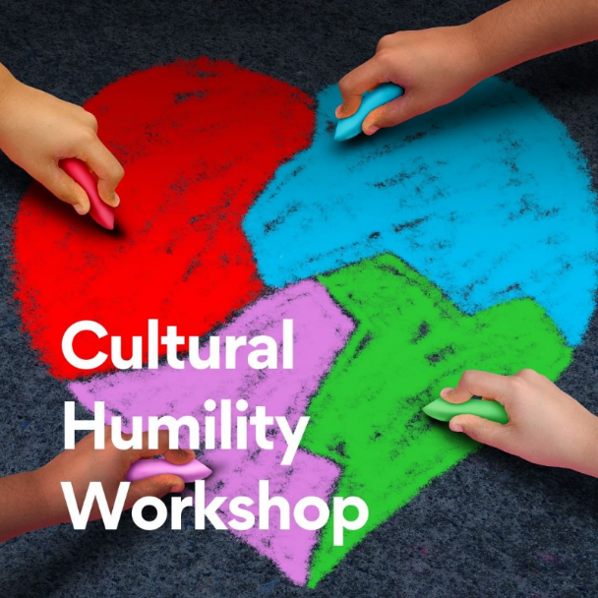

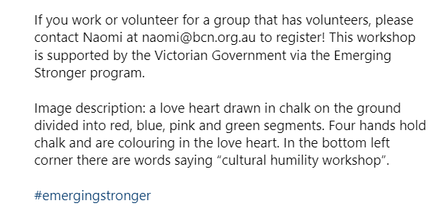

Easy read
Easy Read is written information that is clear and easy to read and understand. Consider using or including an ‘easy read’ option when promoting volunteering opportunities. Easy read uses visuals to support text, less text, larger text and lots of white spaces. Easy read is used by people with a cognitive or learning disability but also people with different literacy levels and people who speak English as an additional language.
Below are some quick tips for easy reading:
- Using everyday language and avoid jargon, acronyms, abbreviations. The Hemingway website is a good tool to check what level of English you are using.
- Order information in a logical way
- Use short, concise sentences
- Use numerals rather than words (e.g., 1 instead of one)
- Use black Arial, size 14
- A white or light background
- Lots of space in between lines and images/graphics.
If you have materials that need to be written via the easy read method, contact the Information Access Group at www.informationaccessgroup.com.

Running events
When you are running volunteering activities or events, there are things that we can do to make people with disabilities feel welcomed, celebrated and valued.
- Consider all options in the ‘design inclusive’ section including if events are being held at accessible locations
- Display posters that show your commitment to inclusivity
- Don’t assume that all disabilities are visible. For example, mental illnesses are invisible and often well hidden
- Ensure that all volunteer coordinators are aware of appropriate language and are aware that other participants may not be aware of this
- Make it clear that anybody can receive support if required. You can also invite people to identify any support requirements when they register, as you would with dietary requirements. If you do this, make it clear why you are asking for this and how you will use the information
- If you receive feedback from people with a disability, be open about recommendations on how best to accommodate their needs
- Talk to all people appropriately – e.g., do not talk to people with disabilities like they are children. Talk to everybody with respect, care and kindness.

Part Five: People who are LGBTIQA+

The acronym ‘LGBTIQA+’ is an evolving term used to describe people with diverse sexualities, genders and sex characteristics [17]. Sometimes the terms ‘LGBT’ or ‘LGBTI’ are used, however the full ‘LGBTIQA+’ is the most inclusive way to reference this community. See the table below:
Lesbian | A woman who is romantically and/or sexually attracted to woman
Gay | A person that is romantically and/or sexually attracted to the same gender – used particularly in reference to men
Bisexual | A person is romantically and/or sexually attracted to people of their own gender or the opposite gender
Transgender | People whose gender identity does not align with the sex they were assigned at birth
Intersex | People have innate sex characteristics that don’t fit medical and social norms for female or male bodies
Queer | An umbrella term that is often used for diverse genders and sexualities.
Asexual | A person does not experience sexual attraction, but may experience romantic attraction towards others
+ | All other forms of sexualities identities like pansexual

In order to understand the diverse aspects of the LGBTIQA+ community, it is imperative that the difference between sex and gender is described. Sex and gender are similar terms and often used interchangeably, but they mean very different things. Sex refers to a person’s biological and anatomical characteristics that are commonly categorised based on things like a person’s chromosomes, reproductive organs and/or hormones [18]. People who are born with variations in these sex traits and are called ‘intersex’ and they may present as having different physical or chromosomal sex presentations that don’t fit medical norms [18].
Gender, on the other hand, is a person’s internal sense of being a boy/man, a girl/woman, both or neither. For most people, gender is tied to biological sex. But gender is also socially constructed and culturally specific. For some people, biological sex doesn’t equate to a specific gender. The word cisgender is used to refer to people whose gender identity aligns with the sex they were assigned at birth. In contrast, the terms transgender and gender diverse are used to describe people whose gender identity does not align with the social expectations of the sex they were assigned at birth [18].
Pronouns are words that an individual wants to use in order to reflect that person's gender identity. You may see pronouns used in email signatures, on name badges and/or people may say them verbally. The pronouns ‘them/them’ are used by people who are non-binary (i.e., feel that they don’t fit into the man/woman spectrum), people who are transgender and/or people who are intersex. People who identify as cisgender may still use pronouns, e.g., ‘she/her’, to normalize the use of pronouns for other peoples and to demonstrate that they will respect other people’s pronouns [19].

Visibility
Research across Australia [20] shows an alarming disparity in health and wellbeing for people in the LGBTIQA+ community when compared to the wider Australian population. This has been attributed to experiences of discrimination, bullying and violence, in addition to a perceived and/or real discrimination when trying to access services such as health care [21]. That is why it is imperative that all people, no matter their gender, sex or sexuality, should be empowered to volunteer in a safe and welcoming space.
Visibility of the LGBTIQA+ community helps to empower the community, educate the public about this diversity and promote equal opportunity and equity for those in the community. The ‘rainbow flag’ and the more recent ‘progressive pride flag’ plays an important role in making the LGBTIQA+ community visible. The flag does not represent each letter in the LGBITQA+ acronym, but rather represents different aspects of the community.
To learn more about the history of the rainbow flag and what it represents, read this article by the Los Angeles Department of Mental Health: click here

You may see people wearing clothes or pins featuring the rainbow flag, the progressive flag shown below, or individual flags such as the lesbian flag, the bisexual flag, etc. As an ally, you are welcome to wear any flag to show your support of the LGBTIQ+ community. Wearing a flag doesn’t mean that you are in the LGBTIQA+ community and doesn’t mean that you have to discuss it if somebody asks.

Figure 6 (below): The Progressive Pride Flag featuring symbols for people who are transgender, intersex and people of colour.

Geelong Rainbow

Geelong Rainbow are a Geelong based not-for-profit established in 2018 that support people in the LGBTIQA+ community, promote and showcase LBGTIQA+ voices and encourage open and transparent channels to nurture community alliances. They offer training, facilitate and promote LGBTIQA+ focused events such as Geelong Pride Month and advocate for LGBTIQA+ causes.

Learn more
Body Safety Australia: https://www.bodysafetyaustralia.com.au/
Geelong Rainbow Inc: www.geelongrainbow.org
Rainbow Health Australia: https://rainbowhealthaustralia.org.au/
The Equality Project: https://www.theequalityproject.org.au/
Thorne Harbour Health: https://thorneharbour.org/

Being Inclusive: Practical Actions

Be collaborative
Working directly and collaboratively with an organization like Geelong Rainbow is a great way to ensure that you are being inclusive. Some benefits of doing so include that you may be able to cross promote your volunteering events, co-lead environmental volunteering or find other ways to assist each other. Some examples are:
  - Linking in with Geelong Rainbow events such as Pride March – there are opportunities to have a stall at the march
  - Running a ‘Rainbow Weeding’ event to showcase that your events and activities are welcoming to those in the LGBTIQA+ community
  - Facilitating training for your volunteer managers or volunteers
  - Seeking support on policies and procedures, inclusivity statements and governance models.

Planning and facilitating volunteering
Design inclusive
To ensure that our volunteering options are in fact accessible and inclusive to all people, we should be designing volunteering opportunities to make them accessible and inclusive. Some things to consider when designing volunteering include:

- Is your volunteering and/or volunteering tasks specific targeted at genders? E.g., many organisations assign tasks that involve heavy lifting or machinery to people who appear as men, when many people are capable of doing so. This creates situations where gender is assumed based on visible perception – i.e., saying ‘you look like a strong man, help me lift this’
- Do you have a policy in place regarding bullying or discrimination that volunteers must abide by? Creating a Code of Conduct and including a strong statement about discrimination or harmful comments allows you to make it clear that a harmful comment or opinion about people in the LGBTIQA+ community will not be tolerated
- Do your general policies or documentation reference genders – i.e., ‘men/women’ or ‘husbands/wives’? Consider using language that is general such as ‘workers’, ‘volunteers’, ‘they’ or ‘partners’
- Does your volunteering occur in a place that has accessible amenities? For example, are your toilets unisex, or do you just have a ‘male’ or ‘female’ option? Having a unisex option, or removing all genders from bathrooms ensures that anybody can feel included and comfortable when using facilities. In addition, consider if all toilets have access to sanitary bins – people who are transgender, gender fluid or intersex may appear typically as ‘male’ but may still menstruate and will need a safe place to dispose of sanitary items. If your volunteering occurs in public spaces like parks or coastal reserves, consider letting your volunteers know if there are gender specific toilets available or not so that they are aware
- Consider if you are reinforcing often harmful stereotypes about genders. For example, are you promoting typically female volunteering on social media by featuring feminine people wearing pink? Are you seeking volunteers to help use an auger to prepare a planting day, by using pictures of strong men?
- The language that you use also plays a part in reinforcing stereotypes and can have harmful impacts on people, especially children. For example, telling boys that they are ‘crying like a girl’ implies that it is not okay for them to express their emotions and can have negative impacts on their mental health in adulthood.

Promoting volunteering
There are many ways to improve promotional methods and materials that are inclusive to the LGBTIQA+ community. Below are some options:
- When engaging volunteers or collaborating with like-minded organisations like Geelong Rainbow, make it clear that you are seeking ‘people’ or ‘volunteers’, not specifically men or women
- Promote your volunteering opportunities with organisations like Geelong Rainbow to have them cross promoted.

Registrations
- If you require volunteers to register and you require their gender, ensure that you include an option/s such as ‘non-binary’, ‘other’ or ‘prefer not to say’. In addition, consider not asking for a volunteers gender at all – do you have a good reason for asking for their gender?
- If you are required to ask for demographics – e.g., age, gender, location – ensure that you explain why at the top of your registration form. Make it clear what this data is used for, how it is stored and who will access it
- Many people have names that are unisex and/or have nothing to do with their visual gender appearance. Examples include ‘Chris’, ‘Mel’ or ‘Robin’ – these could be names for males, females or even non-binary people. Until a person tells you their preferred pronoun, do not assume their gender and instead think of them as ‘they/them.’

Social Media
- Use diverse images of people in your social media posts if possible
- Try and avoid stereotypical wording or visuals in social media. For example, if you are looking for volunteers to help cater an event, consider using neutral language, colours and/or images of people – see Figure 7 below as an example of a typical ‘female’ orientated social media post that reinforces stereotypes vs. a gender-neutral example
- Celebrate LGBTIQA+ dates of significance on your social media to demonstrate your commitment to celebrating and welcoming all people
- Consider adding an acknowledgement of your commitment to inclusiveness on your website, socials, posters, if appropriate via the progress pride flag. See Figure 8 below as an example on using flags on a social media post.

Figure 7 (left): an example of a typical ‘female’ orientated social media post that reinforces stereotypes
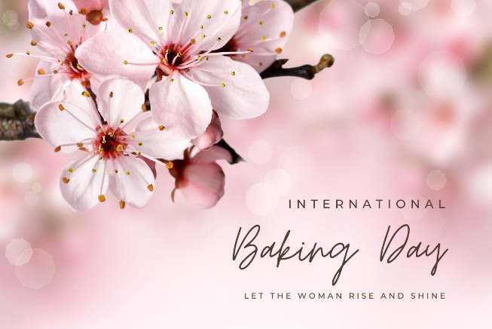
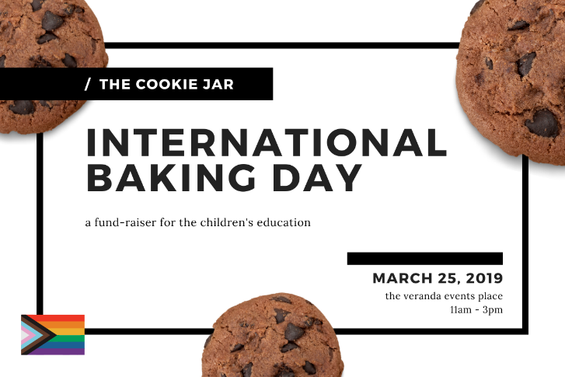
Figure 8 (right): a gender-neutral social media post that also includes a version of the progressive pride flag

Running events
When you are running volunteering activities or events, there are things that we can do to make people in the LGBTIQA+ community feel welcomed, celebrated and valued.
- Consider all options in the ‘design inclusive’ section including if events are being held at accessible locations
- At your events, display visuals such as the poster below and/or wear badges featuring the rainbow or progressive flag to show that you are inclusive and welcoming to all people
- Normalise pronouns by using them. You can practice this by introducing yourself, followed by your pronouns. For example; “Hi my name is Chris and I am she/her.” If you are not comfortable talking about your own pronouns, try avoiding pronouns altogether. For example, use terms like ‘they/them’ or address volunteers by name
- When addressing your audience or volunteers, avoid gendered terms like ‘ladies and gentlemen’ and instead use terms like ‘welcome everybody’, ‘good morning folks’, or even ‘welcome honored guests’. There is no need to reference gender in greetings
- When talking or getting to know your volunteers, don’t assume their partners genders. If it is relevant to discuss or ask a volunteer about their personal life, the word ‘partner’ is an alternative to wife/husband that is generic and inclusive. For example, you may assume that a female appearing person has a husband, but they could be lesbian, bisexual or not even married for that matter! Instead you could say, “what does your partner do for work?”
- If your volunteers include children, you may naturally want to categorize them into ‘boys’ and ‘girls’ if splitting them into groups. Instead, split them via numbers and use terms like ‘galahs’, ‘echidnas’, ‘gum trees’ or other environmental terms and for additional fun!
- If you are providing PPE (Personal Protective Equipment) such as gardening gloves, high visibility vests or hats, choose options that are not gendered. For example, pink high visibility vests reinforce the stereotype that only girls/women like pink.

Other Actions
- If you have volunteers in the LGBTIQA+ community, consider having an authentic and open conversation with them about their experience volunteering, how they can be supported and celebrated and what would help them feel welcomed. Every person has individual experiences, opinions and needs
- Consider booking a training session for your colleagues, volunteer coordinators or volunteers themselves on topics such as gender and sexual diversity. This resource merely discusses this in general terms but understanding the history, current barriers and language in depth is a great way to shift perspectives.

Appendices
- Appendix 3: LGBTIQA+ Flags (sourced from the Los Angeles County Department of Health and Mental Wellbeing)

Conclusion

To ensure that anybody can volunteer to help to improve our local environment for future generations, we must ensure that everybody has the opportunity and freedom to do so. Inclusivity is much more about acquiring more volunteers, but allows us to improve the mental health of people in our community, build social connectivity, celebrate people for who they are, heal and reconcile past pain and gives everybody the chance to connect and care for nature.

Intersectionality
In this resource we have covered communities separately, however in reality many people are part of multiple communities and may experience intersectionality – “social categorizations such as race, class, and gender overlapping and experiencing multiple systems of discrimination or disadvantage.” [22]. An example of intersectionality could be a person who is transgender and disabled not being able to volunteer due to issues with amenities and accessibility. Intersectionality can impact the experiences and needs of people in our community and requires an integrated approach to inclusivity. This resource separates each community into sections for references sake only – in reality, people exist across all 4 communities and so the below section brings it all together.

Bringing it all together
There are many actions featured in this resource that will benefit all people and communities. The following page features a tabled checklist that we encourage you to print and tick off to help you consider inclusivity holistically when designing, promoting and facilitating volunteering opportunities.

Thank you
Bellarine Catchment Network would like to thank everybody who has helped contribute to this document, from heling with the co-design, reviewing content and providing references and resources. We hope that this document provides a guide to inclusivity across the country and across all sectors.
We welcome any additions/ideas and suggestions, so please get in contact with us at:
Bellarine Catchment Network
info@bcn.org.au
www.environmentbellarine.org.au
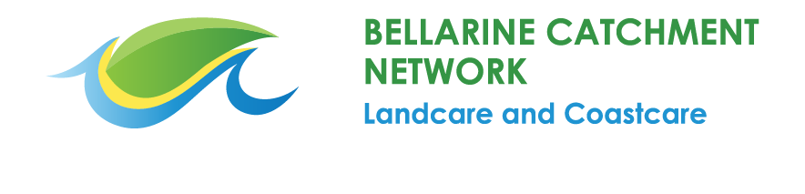

Inclusive Volunteering Checklist

Practical Actions
Make a list of your volunteering opportunities and map out their locations, partners and tasks to use as a basis for the following
Planning
Have you educated yourself about each community and their barriers?
Have you made connections and offers to collaborate between organisations? Could you potentially co-design volunteering opportunities for specific people with these organisations – e.g., people with disabilities?
Have you considered if your volunteering is offering participants the right experience? You may need to talk to participants about this
Do you have policies in place such as a Code of Conduct to manage discrimination?
Do you know what Traditional Owner Country you are volunteering on?
Have you acquired any cultural heritage permits or approvals?
Are you promoting local Traditional Owners by using approved language?
Do you have plans to engage the services from businesses from First Nations, disability, CALD and/or LGBTIQA+ communities?
Do you have accessible facilities at your activity (unisex/disability toilets)?
Is your volunteering accessible via public transport?
Are your activities gender selective and/or specific?
Is your chosen location easy to navigate for people who may find rough terrain difficult?
Have you chosen a location that is accessible with accessible and inclusive toilets and parking?
Can you create tasks for informal/flexible volunteering (bringing a plate, social media, volunteering from home)?
Have you applied for funding to cover costs like interpreters?
Have you considered linking into to existing events like Pride events in March?
Consider running specific events that promote the groups you are working with – e.g., ‘rainbow weeding’

Promotion
Have you clearly described the requirements and conditions of volunteering, including what is going to happen?
Are you using gender neutral language in promotions and/or visuals?
Have you considered how you are wording volunteering and the benefits? Consider promoting benefits like building social connection, pathways to employment
Have you used easy read or simple language in volunteer promotions?
Have you provided information about volunteering in accessible formats like Word Docs?
Are you sharing these opportunities with organisations like GenU and Cultura?
Are your volunteering opportunities available for everybody, i.e., are not gender-targeting
Are the photos of people you are using diverse?

Registration
Does your registration form ask for the volunteer’s gender? Consider removing this question or adding options like ’Non-binary’ or an open ‘other’ field
Does your registration form explain why you may need to conduct a police check and how that information is to be used?
Does your registration form include a question where people can list what support they may require including things like adjustments or interpreters?

Social Media
Are you mentioning the Traditional Owner Country in your social media posts?
Have you designed your social media copy to look friendly (i.e., not official looking)?
Are you showing your commitment to inclusivity in other social media posts to demonstrate your authenticity?
Does your social media include images that reflect diverse people?
Are your social media posts gender-neutral?
Are you using alternative text in social media posts for people who use screen readers?
When celebrating your volunteering, are you focusing on the person and not their disability?
Do your social media posts use easy language without jargon, acronyms or sarcasm?

Facilitating Volunteering
Have you prepared and willing to conduct an Acknowledgement of Country?
Are you displaying First Nations or LGBTIQA flags or diversity posters?
Are you welcoming people in languages other than English?
Are you stating your pronouns when introducing yourself?
Are you welcoming your volunteers in a gender-neutral way?
Have you provided enough Personal Protective Equipment (PPE) and resources for those who may not have it? Is this PPE in a mix of sizes to suit all people?
Is your food halal friendly? Have you considered any other dietary requirements – e.g., the fact that volunteers may be participating in Ramadan?
Are you talking to everybody with respect, care and kindness?
Are you talking to volunteers who speak English as an additional language, speaking slowly and clearly and demonstrating active listening?
Are volunteer coordinators briefed in how they can support people with disabilities/CALD communities?
If requiring people to work in teams, are you using fun team names that aren’t gender-related (e.g., galahs vs. echidnas)?
Do you have a way of capturing feedback so that you can improve opportunities in the future? The more conversations you have with diverse volunteers, the more likely you will find ways to improve your inclusivity.

Appendix 1: Wadawurrung Word List

Greetings
Gobata | Take care
Koling Wada-ngal | Let’s walk together
Nyatne | Thank you

Locations
Barwong | Barwon River
Bellawiyn | Bellarine
Bengala | Indented Head
Boronggook | Drysdale
Djilang | Geelong
Gowayn | Point Lonsdale
Korayn | Corio
Nherrin-boor-woorook | Queenscliff
Youang | You Yangs

Environment
Dja | Country
Ngubitj/Warre | Water/ocean
Yulluk/Yaluk | Waters or waterway

Appendix 2: Language Guides - Swahili

It is recommended that you use the following language guides in combination with google translate to help with pronunciation.
English | Swahili
Hello | Habari
Welcome | Karibu
How are you? | Hujambo
My name is _______ | Jina langu ni ……..
What is your name ________ | Unaitwa nani?
Please gather around | Tafadhali, kusanyikeni karibu
Would you like assistance? | Je unahitaji msaada?
Who should I call in an emergency? | Je niwasiliane na nani wakati wa dharura?
Do you have an email address? | Je una anuani ya barua pepe?
Do you have any allergies? | Je una mizio/allergies?
Thank you | Ahsante/Asante
Thank you for helping today | Asante kwa kusaidia leo
Did you enjoy yourself? | Je, ulifurahia mwenyewe
The toilets are ______ | Chooni/Vyoo ni -------
Please enjoy this food/drink | Tafadhali furahia chakula/kinywaji hiki
What language do you speak? | Ni lugha gani unazungumza?
I am from [Nationality] | Natokea nchi…. (Uraia)

Good | Nzuri
Okay | Sawa
Bad | Mbaya
Yes | Ndio
No | Hapana
I need | Nahitaji
Assistance/help | Msaada
Water | Maji
Food | Chakula
Where are the toilets? | Vyoo viko wapi?
I am hurt/injured | Nimeumia

Appendix 2: Language Guides - Arabic

It is recommended that you use the following language guides in combination with google translate to help with pronunciation.

English | Arabic (written) | Arabic (spoken)
Hello | مرحبا | Marhaba
Welcome | أهلا وسهلا | Ahlan wa sahlan
How are you? | كيف حالك؟ | Kayf halik?
My name is _______ | _______: اسمي | Ismi _______
What is your name ________ | ________: ما هو اسمك | Ma ismuka ________
Please gather around | يرجى التجمع | Yurajaa altajamuu
Would you like assistance? | هل ترغب في المساعدة؟ | Hal turidu almusaeadah?
Who should I call in an emergency? | من يجب أن أتصل به في حالة الطوارئ؟ | Man yajib 'an ‘atasil bih fi halat alttawari’?
Do you have an email address? | هل لديك عنوان بريد إلكتروني؟ | Hal ladayk eanadatan barid 'iilaaiktruniyah?
Do you have any allergies? | هل لديك أي حساسية؟ | Hal ladayk 'iijabiat sihhiat?
Thank you | شكراً لك | Shukran lak
Thank you for helping today | شكراً لمساعدتك اليوم | Shukran limusaeadatik alyawm
Did you enjoy yourself? | هل استمتعت؟ | Hal istamtaeata?
The toilets are ______ | ______: الحمامات | Alhamamat _______
Please enjoy this food/drink | استمتع بهذا الطعام / هذا المشروب | Astamti’i bihadha alttaeam / hadha almashrub
What language do you speak? | ما هي اللغة التي تتحدثها؟ | Ma hiya allughat allati tatuhaddithu biha?
I am from [Nationality] | أنا من [الجنسية] | Ana min [aljinsiyah]

Good | جيد | Jayyid
Okay | حسناً | Tamam
Bad | سيئ | Sayyi’
Yes | نعم | Na’am
No | لا | La
I need | أحتاج | 'Ahtaju
Assistance/help | مساعدة | Musa’ada
Water | ماء | Ma’
Food | طعام | Ta’am
Where are the toilets? | أين المراحيض؟ | 'Ayna al-maraahid?
I am hurt/injured | أنا مصاب/مجروح | 'Anaa majruuh/musii’b

Appendix 2: Language Guides - Persian

It is recommended that you use the following language guides in combination with google translate to help with pronunciation.

English | Persian (written) | Persian (spoken)
Hello | سلام | Sa-laam
Welcome | خوش آمدید | Khosh aa-ma-did
How are you? | حالت چطوره؟ | Ha-let che-to-re
My name is _______ | اسم من -------هست. | Es-me man ----------hast
What is your name ________ | اسم تو چیه؟ | Es-me to chi-ye?
Please gather around | لطفا دور هم جمع بشید. | Lot-fan do-re ham jam be-sheed.
Would you like assistance? | دوست داری کمک کنی؟ | Doost da-ri ko-mak ko-nee?
Who should I call in an emergency? | تو موقعیت اضطراری به کی زنگ بزنم؟ | Za-ma-ne ez-te-ra-ri be kee zang be-zanam
Do you have an email address? | آیا ای-میل داری؟ | Aa-ya e-mail da-ri?
Do you have any allergies? | آیا آلرژی یا حساسیت داری؟ | Aa-ya A-ler-gy da-ri?
Thank you | متشکرم. | Mo-chak-ker-ram
Thank you for helping today | ممنونم برای کمک امروزت. | Mam-noo-nam ba-ra-ye ko-ma-ke em-roo-zet.
Did you enjoy yourself? | آیا لذت بردی؟ | Aa-ya Lez-zat bor-di?
The toilets are ______ | توالت------------- هست. | Tuh-vaa-let -------------------- hast.
Please enjoy this food/drink | لطفا این غذا یا نوشیدنی را بفرمايید. | Lot-fan in qa-zaa ya Noo-shee-da-nee ra be-far-maa-id.
What language do you speak? | به چه زبونی شما صحبت میکنی؟ | Be che Za-boo-nee soh-bat mee-ko-nee?
I am from [Nationality] | من از }ملیت{ هستم. | Man az ---------------- has-tam.
What is your phone number? | شماره تلفنت چیه؟ | Sho-maa-re te-le-pho-net chee hast?

Good | خوب | Qoob- Khoob
Okay | اوکی | OK
Bad | بد | Bad
Yes | بله | Ba-le
No | نخیر | Naa
I need | من لازم دارم. | Man Laa-zem Daa Ram
Assistance/help | دستیار/ کمک | Das-t-yar
Water | آب | Aab
Food | غذا | Gha-za
Where are the toilets? | توالت کجاست؟ | To-vaa-let ko-jas
I am hurt/injured | من آسیب دیدم. | Maan a-seeb Dee-dam
Please help me. | لطفا به من کمک کنید. | Lot-fan be Man Ko-mak Ko-need?

Appendix 3: LGBTIQA+ Flags

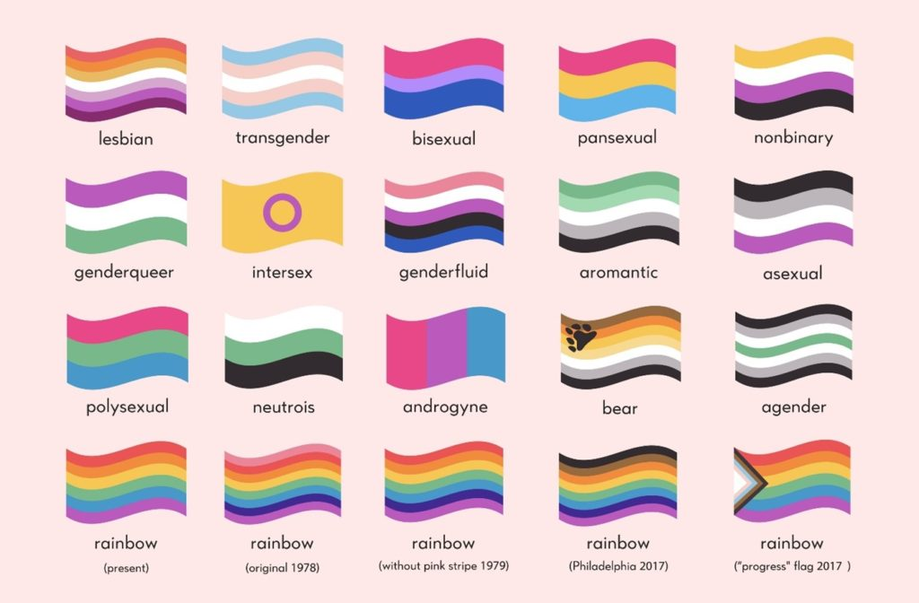

References

[1] Australian Human Rights Commission, ‘Unconscious Bias and the Bamboo Ceiling’, 2014 - link
[2] The Culture Movement ‘Circuit Breaking Unconscious Bias’, 2020 - link
[3] AIATSIS, ‘Australia’s First Peoples’, 2022 - link
[4] Aboriginal Heritage Council, ‘Victoria's Current Registered Aboriginal Parties’, 2021 - link
[5] Wadawurrung Traditional Owners Aboriginal Corporation, 2023 – link
[6] Paleert Tjaara Dja – ‘Let’s Make Country Good Together – Wadawurrung Country Plan’, 2019
[7] Reconciliation Australia, ‘Acknowledgement of Country and Welcome to Country’ - link
[8] National Indigenous Australians Agency, ‘Welcome to Country or Acknowledgement of Country’ - link
[9] Victorian Government, ‘Data Collection Standards - Culturally and Linguistically Diverse communities’ - link
[10] Cultura Australia, Anecdotal Evidence, 2023
[11] University of Oregon, ‘What is Cultural Humility? The Basics’ - link
[12] Cultura, ‘Cultural Humility Training’, 2022
[13] Sacred Heart University, ‘Cultural Humility vs. Cultural Competence: A Lifelong Journey’ - link
[14] People With Disability Australia, ‘PWDA Language Guide: A Guide to Language About Disability’, 2021 - link
[15] Department of Health, ‘Dual Disability’, 2015 - link
[16] People with Disability Australia – ‘Social Model of Disability’ - link
[17] The Equality Project, ‘LGBTIQA 101’ - link
[18] Rainbow Health Victoria, ‘Research Matters: What Does LGBTIQ Mean?’, 2020 - link
[19] Minus 18, ‘What Are Pronouns and Why Are They Important?’, 2022 - link
[20] LGBTIQA+ Health Australia, ‘Snapshot of Mental Health and Suicide Prevention Statistics for LGBTIQ+ People’, 2021 - link
[21] LGBTIQA+ Health Australia, ‘National LGBTIQ+ Mental Health and Suicide Prevention Strategy’, 2021 - link
[22] Wikipedia, ‘Intersectionality’ - link

